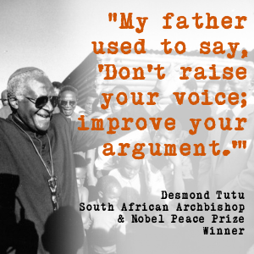
Senior Level
Persuasive Essay
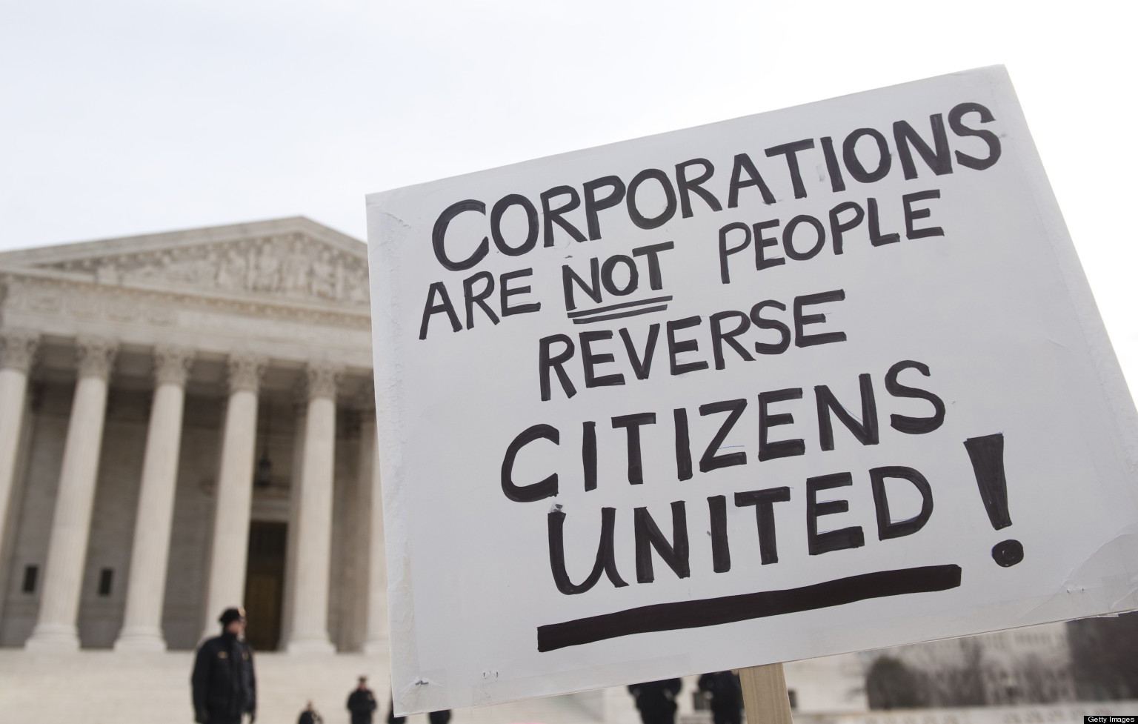
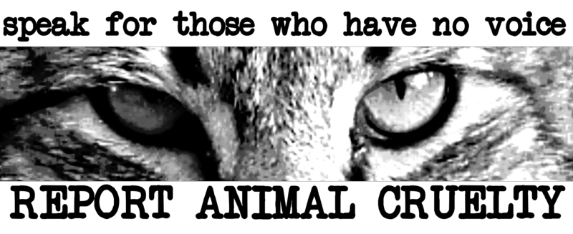

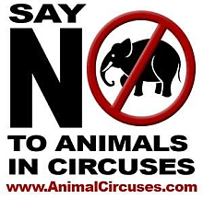

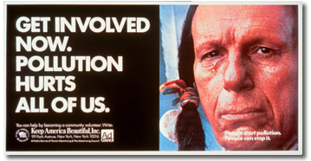

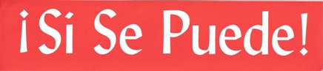
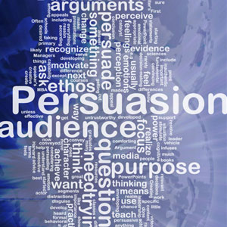

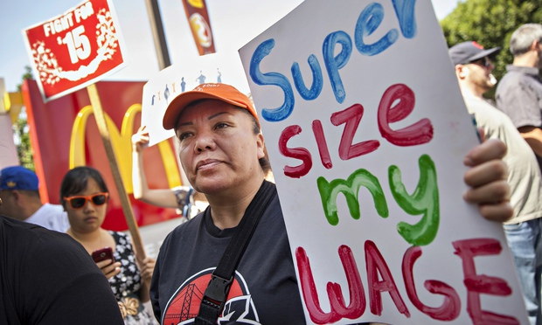
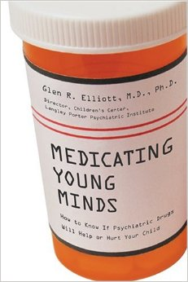

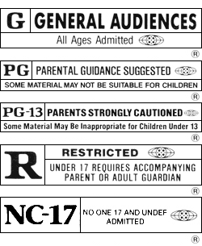
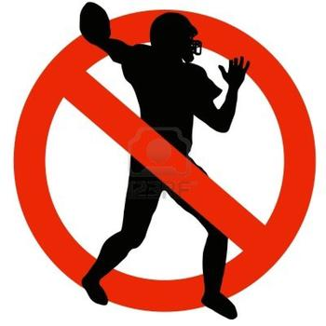

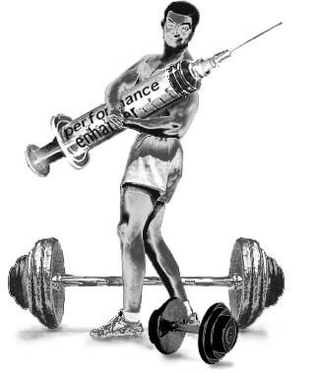

Name: ___________________________________________
Period: ______
Senior Level Persuasive Essay

Assignment:

You will choose one societal issue that is important to you and that you feel strongly about. Once you have chosen the topic, you will:

1. Complete all parts of the Persuasive Writing packet as assigned.
2. Research to find newspaper/magazine articles, books (hard copy and/or on-line) and websites.
3. Organize your essay in the required five-paragraph format.
4. Obtain peer edits of your rough drafts as assigned.
5. Submit a final draft by the deadline.

Essay Requirements:

1. Your packet with ALL pages completed to show evidence of process and research

2. A strong thesis statement: subject and opinion (also called commentary)

3. A tie to written and/or unwritten law

4. A total of six statistics, facts and quotes from the following sources:

a. A minimum of two newspaper and/or magazine articles from EXPLORA (EBSCO)
b. A minimum of two websites
d. One video/media source.
e. One source you choose. (Can be any of the above.)

5. Written with an academic tone without the use of personal pronouns: I, me, you, your, we, us

6. Contain counterpoints at the end of each body paragraph

7. A “Call to Action” in the concluding paragraph

Name: _____________________________________
Date: _____
Period: _____

Persuasive Writing Essay Topics

What is a persuasive writing? In persuasive writing, a writer takes a position FOR or
AGAINST an issue and writes to convince the reader to believe or do something.
Persuasive writing uses logic and reason to show that one idea is more legitimate than another idea. It attempts to persuade a reader to adopt a certain point of view or to take a particular action. The argument must always use sound reasoning and solid evidence by stating facts, giving logical reasons, using examples, and quoting experts.

This is a senior level requirement for passing English 4. You will do most of the pre-writing and drafting in class. You must complete each daily assignment for the points in this unit. Since we do much of the planning, pre-writing and drafting in-class, it is important that you aren’t absent and that you don’t fall behind. It’s possible some of you may need to use tutors in the library after school to get help. While I intend to work with each of you individually, I can’t always devote the individual time you may need during class.

Instructions: You will choose one societal issue that is important to you and that you feel strongly about for your persuasive essay. Highlight or put a star next to 5 topics that appeal to you.

* Should children be given sex education in schools, or should this be the responsibility of the parents?
* Are prisons the only answer to criminal behavior?
* Should parents be held legally responsible for the actions/needs of their children?
* Should minors be subjected to curfews as a way to reduce crime?
* Should doctors be allowed to prescribe contraception, Plan B pills or perform abortions for girls under the age of 18 without parental consent?
* Should government prevent minors from purchasing music that is violent or expletive?
* Is there a link between violent video games and acts of violence?
* Is it morally acceptable to experiment on non-human animals to develop products and medicines that benefit human beings?
* Should we ban the keeping of animals in zoos?
* Should there be dog breed restriction laws?
* Should assisted suicide be legalized?
* Should the use of performance-enhancing drugs in sports be legalized?
* Should the drinking age be lowered?
* Should schools drug test athletes?
* Are undocumented immigrants criminals and social and economic burdens to law-abiding, tax-paying Americans?
* Are contact sports too dangerous for minors?
* Should public schools require uniforms?
* Should athletes with prosthetics be able to compete in school, college and professional sports?
* Should death penalty executions be televised? (You would research about other countries that do this.)
* Should police officers be required to undergo military training?
* Should the path to becoming a documented citizen of the United States be changed?
* Is it ethical for corporations to market unhealthy products on school campuses?
* Should minors be able to get tattoos without parental consent?
* Should the use of green energy be required at all public schools?
* Should school lunches be improved?
* Should music and art programs be eliminated?
* Should sports be eliminated from schools?
* Should GMO’s be banned?
* Should requirements for organic food labeling change?
* Should offshore drilling be banned?
* Should there be an age limit to purchase energy drinks or coffee drinks?
* Should fast food companies be held legally accountable for health conditions?
* Should cities offer bike-sharing programs?
* Should people who download music and movies illegally be punished?
* Are electronic devices bad for our health?
* Should standardized tests determine a students learning?
* Should the government add an extra tax for fatty snacks and junk food?
* Should citizens be allowed to have assault weaponry, based on the 2nd amendment?
* Would it be better if schools started later in the morning?
* Should it be legal for people to own exotic pets? (monkeys, tigers, lemurs, etc.)
* Is it wrong for mass media to promote a specific beauty standard? (one body shape, long hair, thin, tall, etc.)
* Should the state fund schools run by particular faiths?
* Are beauty contests harmful?
* Does the Internet influence young people to engage in risky behavior?
* Should parent-spectators be required to sign a “Spectator Expectation Code of Conduct,” which includes prohibitions against verbal abuse and obnoxious behavior?
* Are rating systems for music, movies and/or video games a form of censorship?
* Should daylight savings time be eliminated?

Topics not on this list must be approved by the teacher and must be written in question form. Use the space below to write the topic and turn it into a question like those above.

___________________________________________________________________________________________________________________________________________________________________________________________________________________________________________________________________________________________________________________________________________________________________________________________________________________________________________________

Name: _____________________________________
Date: _____
Period: _____
Thesis Statement Generator

1. A thesis statement is a general sentence with a subject and an opinion (also called commentary).

Example: Australia is the best country for a vacation.

In this sentence, Australia is the subject. The rest of this sentence tells the writer’s opinion, or commentary, about it—that it’s the best country for a vacation.

2. REVIEW

A thesis statement is a general sentence with a __________________________________ and an

_______________________________ (also called __________________________).

3. PRACTICE

For each of the following thesis statements, underline the subject once and the opinion (commentary) twice.

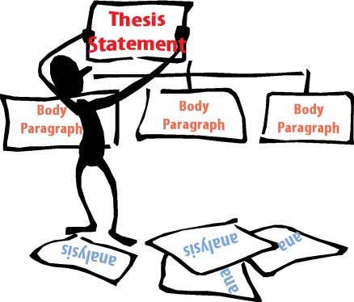
Example: UCLA is the best place to go to school.

a) Popeye’s chicken is better than Kentucky Fried chicken.

b) English is my favorite class.

c) Disneyland is the best place for a family vacation.

d) Tacos are my favorite food.

4. REVIEW

What are the 2 parts to a thesis statement?

A thesis statement is a general sentence with a __________________________________ and an

_______________________________ (also called __________________________).

5. PRACTICE

Now you will narrow your 10 choices and write 4 thesis statements from the Persuasive Topics List. You will change the question to a thesis statement that reflects your opinion (also called commentary) in the format you practiced above. Write SMALL.

1. _____________________________ __________________________________________________________________________.
Subject Opinion

2. _____________________________ __________________________________________________________________________.
Subject Opinion

3. _____________________________ __________________________________________________________________________.
Subject Opinion

4. _____________________________ __________________________________________________________________________.
Subject Opinion

6. FINAL STEP

Write the thesis statement that you will write about for your Senior Persuasive Essay.

_______________________________ __________________________________________________________________________.
Subject Opinion

Eliminating Personal Pronouns
you, your I, we, me, us, my, mine, our, and ours

Persuasive writing is formal in tone and meant to be objective, using cited sources to support an argument or position. You and your carries a tremendous sense of informality, and in a sentence that gives advice or demands action, it may seem outright aggressive.

Unless it is in a direct quote, you and your cannot be used in your persuasive essay.

Review the following sentences, taken from student responses to an underage drinking prompt. Revise the pronoun choice in the sentence. You may have to re-write the sentence and address general “wordiness.”

1. When you are a teen, your social health is very important.
____________________________________________________________________________________________________________________________________________________________________________________________________

2. When you set your mind to the fact that you can depend on alcohol you lose focus on the real things that matter in life. ____________________________________________________________________________________________________________________________________________________________________________________________________

3. If a teen has a criminal charge on your record, that could hurt your chances of getting a job that you may want. Legal charges can really hurt your lifestyle.
____________________________________________________________________________________________________________________________________________________________________________________________________

4. Having a criminal record makes it hard to prepare for your future in a responsible way. It is also known that if you have a record, a judge won’t be quite as lenient.
____________________________________________________________________________________________________________________________________________________________________________________________________
____________________________________________________________________________________________________________________________________________________________________________________________________

Using I, we, me, my, us, weakens the credibility of the writer in research and argument.

Review the following sentences. Revise the pronoun choice in the sentence. You may have to re-write the sentence and address general “wordiness.”

1. I am writing this paper to discuss how I believe climate change is a major problem.
____________________________________________________________________________________________________________________________________________________________________________________________________

2. I believe computers should be banned due to the risk they pose to us.
____________________________________________________________________________________________________________________________________________________________________________________________________

3. My opinion is that we should be able to drink if we are old enough to vote or join the military.
____________________________________________________________________________________________________________________________________________________________________________________________________

4. Animal testing doesn’t really offend me. We should test animals instead of testing us humans.
____________________________________________________________________________________________________________________________________________________________________________________________________

5. If you play video games, then you might get violent.
____________________________________________________________________________________________________________________________________________________________________________________________________

Persuasive Research
saclibrary.org
Name: ___________________________________________________

Topic: ___________________________________________________

Thesis Statement: __________________________________________________________________________
__________________________________________________________________________

Essay Requirement: Ultimately you will use a total of 6 internal citations in your essay. These will include direct or paraphrased quotes, facts, and/or statistics (two per body paragraph). The purpose of the activity below is for you to gather research options for your persuasive essay. You will complete all steps below to ensure you have an adequate amount of information to choose from.

Minimum Essay Source Requirements:
a. A minimum of two newspaper and/or magazine articles from EXPLORA (EBSCO)
b. A minimum of two websites
d. One video/media source.
e. One source you choose. (Can be any of the above.)

1. EBSCO/EXPLORA: How to Cite a Newspaper & Magazine Database On-line in MLA

Essay Requirement: Ultimately, you will use a minimum of TWO newspapers and/or magazines as sources for your essay. You are citing 4 below so you have options for your research.

a) Citing a database online:

Last, First M. "Article Title." Database Name. Database Publisher, Date Month Year Published. Web. Date Month Year Accessed.

Find five articles from newspapers and/or magazines and write down the Title MLA citation below.

1.________________________________________________________________________________________________________
_______________________________________________________________________________________________________

2.________________________________________________________________________________________________________
_______________________________________________________________________________________________________

3.________________________________________________________________________________________________________
_______________________________________________________________________________________________________

4.________________________________________________________________________________________________________
_______________________________________________________________________________________________________

2. WEBSITE: How to Cite a Website in MLA

a) Citing a website with an author:

Last, First M. “Article Title.”Website Title. Website Publisher, Date Month Year Published. Web. Date Month Year Accessed.
b) Citing a website without an author:
Example:
“India.” Travel.State.Gov. Bureau of Consular Affairs, U.S. Department of State, 17 Feb. 2010. Web. 4 May 2010.
Using the citation formats above, find 4 websites with information that you can use in your persuasive essay.
1. _________________________________________________________________________________________________________
2. _________________________________________________________________________________________________________
3. _________________________________________________________________________________________________________
4. ________________________________________________________________________________________________________
3. VIDEO/MEDIA: How to Cite a Film or Video in MLA
To cite a film or video, use the following structure:
Last name, First name of the creator. “Title of the film or video.” Title of the website, role of contributors and their First name Last name, Version, Numbers, Publisher, Publication date, URL.
Example(s):
RotoBaller. “RotoBaller MLB: Top Fantasy Baseball Catcher Dynasty League Prospects for 2016.” YouTube, commentary by Raphael Rabe, 27 Mar. 2016, youtu.be/gK645_7TA6c.
“Lunch Hour NYC: Hot Dog Carts.” New York Public Library, 5 July 2012, www.nypl.org/audiovideo/hot-dog.

4. BOOK: How to Cite a Book in Print or Online Book in MLA (Optional)

a) Citing a book:

Last, First M. Book. City: Publisher, Year Published. Print.

b) Citing an online book:

Last, First M. Book. City: Publisher, Year Published. Website Title. Web. Day Month Year Accessed.

5. What laws exist about your topic? Local, State or Federal?

Write down a current law or laws about your topic. You may cite a federal or state Supreme Court case or a local ordinance. Laws may also be in the form of Education Code, Sports Organization laws, government regulations.
____________________________________________________________________________________________________________________________________________________________________________________________________________________________________________________________________________________________________________________________________

Website Evaluation Form
Site Name: __________________________________________________________
Site Address/URL: http// __________________________________________________________________
Respond to all questions below. Leave blank for any question that does not apply.

Consider WHO is responsible for the website:
- Does the publisher appear to be knowledgeable about the content? _____ YES _____ NO
- Does the publisher qualify as an authority or expert on the topic? _____ YES _____ NO
- Can you contact the publisher from the site? _____ YES _____ NO
- Is the site’s sponsor identified? _____ YES _____ NO

Consider WHAT is the content/subject matter of the website:
- Does the content appear to be accurate? Error free? _____ YES _____ NO
- Is the information presented in an objective manner, with a minimum bias? _____ YES _____ NO
- Is there real depth-of-content (vs. information that is limited and superficial)? _____ YES _____ NO
- Are links from the website appropriate and/or supportive of the content? _____ YES _____ NO
- Does the content have educational or informational value? _____ YES _____ NO

Consider WHERE the website resides:
- What type of domain is this site?
___ .gov ___ .com ___.edu ___.org ___ .net ___ .biz Other: ___
- Is this someone’s personal page with a “~” or “.name” in the URL _____ YES _____ NO

Consider WHEN the website was last updated:
- Is the information current? _____ YES _____ NO
- Does the site provide information on when it was last updated? _____ YES _____ NO
- Does a current date matter? _____ YES _____ NO

Consider HOW the main page looks and functions:
- Is the page easy to understand and use? _____ YES _____ NO
- Is the page well organized? _____ YES _____ NO
- Does the page load in a reasonable amount of time? _____ YES _____ NO
- Do all of the links work? _____ YES _____ NO
- Is the page free from (excessive amounts of) advertising? _____ YES _____ NO

Consider WHY the website exists:
- Is the site trying to
sell something? _____ YES _____ NO
inform? _____ YES _____ NO
persuade? _____ YES _____ NO
- Is the website appropriate for your target audience? _____ YES _____ NO
- Is the Internet the best place to find this information (vs. books, journals, etc.)? _____ YES _____ NO

Conclusion: Is this a good website? Look over your answers to make your conclusion. _____ YES _____ NO

Website Evaluation Form
Site Name: __________________________________________________________
Site Address/URL: http// __________________________________________________________________
Respond to all questions below. Leave blank for any question that does not apply.

Consider WHO is responsible for the website:
- Does the publisher appear to be knowledgeable about the content? _____ YES _____ NO
- Does the publisher qualify as an authority or expert on the topic? _____ YES _____ NO
- Can you contact the publisher from the site? _____ YES _____ NO
- Is the site’s sponsor identified? _____ YES _____ NO

Consider WHAT is the content/subject matter of the website:
- Does the content appear to be accurate? Error free? _____ YES _____ NO
- Is the information presented in an objective manner, with a minimum bias? _____ YES _____ NO
- Is there real depth-of-content (vs. information that is limited and superficial)? _____ YES _____ NO
- Are links from the website appropriate and/or supportive of the content? _____ YES _____ NO
- Does the content have educational or informational value? _____ YES _____ NO

Consider WHERE the website resides:
- What type of domain is this site?
___ .gov ___ .com ___.edu ___.org ___ .net ___ .biz Other: ___
- Is this someone’s personal page with a “~” or “.name” in the URL _____ YES _____ NO

Consider WHEN the website was last updated:
- Is the information current? _____ YES _____ NO
- Does the site provide information on when it was last updated? _____ YES _____ NO
- Does a current date matter? _____ YES _____ NO

Consider HOW the main page looks and functions:
- Is the page easy to understand and use? _____ YES _____ NO
- Is the page well organized? _____ YES _____ NO
- Does the page load in a reasonable amount of time? _____ YES _____ NO
- Do all of the links work? _____ YES _____ NO
- Is the page free from (excessive amounts of) advertising? _____ YES _____ NO

Consider WHY the website exists:
- Is the site trying to
sell something? _____ YES _____ NO
inform? _____ YES _____ NO
persuade? _____ YES _____ NO
- Is the website appropriate for your target audience? _____ YES _____ NO
- Is the Internet the best place to find this information (vs. books, journals, etc.)? _____ YES _____ NO

Conclusion: Is this a good website? Look over your answers to make your conclusion. _____ YES _____ NO

Website Evaluation Form
Site Name: __________________________________________________________
Site Address/URL: http// __________________________________________________________________
Respond to all questions below. Leave blank for any question that does not apply.

Consider WHO is responsible for the website:
- Does the publisher appear to be knowledgeable about the content? _____ YES _____ NO
- Does the publisher qualify as an authority or expert on the topic? _____ YES _____ NO
- Can you contact the publisher from the site? _____ YES _____ NO
- Is the site’s sponsor identified? _____ YES _____ NO

Consider WHAT is the content/subject matter of the website:
- Does the content appear to be accurate? Error free? _____ YES _____ NO
- Is the information presented in an objective manner, with a minimum bias? _____ YES _____ NO
- Is there real depth-of-content (vs. information that is limited and superficial)? _____ YES _____ NO
- Are links from the website appropriate and/or supportive of the content? _____ YES _____ NO
- Does the content have educational or informational value? _____ YES _____ NO

Consider WHERE the website resides:
- What type of domain is this site?
___ .gov ___ .com ___.edu ___.org ___ .net ___ .biz Other: ___
- Is this someone’s personal page with a “~” or “.name” in the URL _____ YES _____ NO

Consider WHEN the website was last updated:
- Is the information current? _____ YES _____ NO
- Does the site provide information on when it was last updated? _____ YES _____ NO
- Does a current date matter? _____ YES _____ NO

Consider HOW the main page looks and functions:
- Is the page easy to understand and use? _____ YES _____ NO
- Is the page well organized? _____ YES _____ NO
- Does the page load in a reasonable amount of time? _____ YES _____ NO
- Do all of the links work? _____ YES _____ NO
- Is the page free from (excessive amounts of) advertising? _____ YES _____ NO

Consider WHY the website exists:
- Is the site trying to
sell something? _____ YES _____ NO
inform? _____ YES _____ NO
persuade? _____ YES _____ NO
- Is the website appropriate for your target audience? _____ YES _____ NO
- Is the Internet the best place to find this information (vs. books, journals, etc.)? _____ YES _____ NO

Conclusion: Is this a good website? Look over your answers to make your conclusion. _____ YES _____ NO

Website Evaluation Form
Site Name: __________________________________________________________
Site Address/URL: http// __________________________________________________________________
Respond to all questions below. Leave blank for any question that does not apply.

Consider WHO is responsible for the website:
- Does the publisher appear to be knowledgeable about the content? _____ YES _____ NO
- Does the publisher qualify as an authority or expert on the topic? _____ YES _____ NO
- Can you contact the publisher from the site? _____ YES _____ NO
- Is the site’s sponsor identified? _____ YES _____ NO

Consider WHAT is the content/subject matter of the website:
- Does the content appear to be accurate? Error free? _____ YES _____ NO
- Is the information presented in an objective manner, with a minimum bias? _____ YES _____ NO
- Is there real depth-of-content (vs. information that is limited and superficial)? _____ YES _____ NO
- Are links from the website appropriate and/or supportive of the content? _____ YES _____ NO
- Does the content have educational or informational value? _____ YES _____ NO

Consider WHERE the website resides:
- What type of domain is this site?
___ .gov ___ .com ___.edu ___.org ___ .net ___ .biz Other: ___
- Is this someone’s personal page with a “~” or “.name” in the URL _____ YES _____ NO

Consider WHEN the website was last updated:
- Is the information current? _____ YES _____ NO
- Does the site provide information on when it was last updated? _____ YES _____ NO
- Does a current date matter? _____ YES _____ NO

Consider HOW the main page looks and functions:
- Is the page easy to understand and use? _____ YES _____ NO
- Is the page well organized? _____ YES _____ NO
- Does the page load in a reasonable amount of time? _____ YES _____ NO
- Do all of the links work? _____ YES _____ NO
- Is the page free from (excessive amounts of) advertising? _____ YES _____ NO

Consider WHY the website exists:
- Is the site trying to
sell something? _____ YES _____ NO
inform? _____ YES _____ NO
persuade? _____ YES _____ NO
- Is the website appropriate for your target audience? _____ YES _____ NO
- Is the Internet the best place to find this information (vs. books, journals, etc.)? _____ YES _____ NO

Conclusion: Is this a good website? Look over your answers to make your conclusion. _____ YES _____ NO

Persuasive Essay Terminology
1 | ESSAY | A piece of writing that gives your opinion (commentary) about a subject. Includes 5 paragraphs: Introduction, 3 body paragraphs, and a concluding paragraph.
2 | INTRODUCTORY  PARAGRAPH | The first paragraph in an essay. Hook (question, anecdote, statistic), commentary, and thesis statement is at the end of the paragraph.
3 | BODY PARAGRAPHS | The middle paragraphs in an essay. It develops a point you want to make that supports your thesis.
4 | CONCLUDING PARAGRAPH | The last paragraph of your essay. All commentary and does not include concrete detail. It does not repeat key words from your paper and especially not from your thesis and introductory paragraph. It gives a finished feeling to the whole essay.
5 | THESIS | A sentence with a subject and opinion (also called commentary) This comes at the end of your introductory paragraph.
6 | PRE-WRITING  RESEARCH | The process of getting your concrete details from your research on paper before your organize your essay into paragraphs. You can use any or all of the following: bubble clusters, outlines, graphic organizers.
7 | TOPIC SENTENCE | The first sentence in a body paragraph. This must have a subject and opinion (commentary) for the paragraph. It does the same thing for a body paragraph that a thesis does for the whole essay.
8 | CONCRETE DETAILS  (CD) | Specific details that form the proof or core of your body paragraphs. Can include: facts, specifics, examples, support, proof, evidence, quotations, and/or paraphrasing.
9 | COMMENTARY  (CM) | Your opinion or comment about something; not concrete detail. Can include: opinion, insight, analysis, interpretation, inference, evaluation, explication and/or reflection.
10 | CHUNK | One sentence of concrete detail and 2 sentences of commentary. It is the smallest unified group of thoughts that you can write. Two chunks per body paragraph are required. Ratio: 1 part concrete detail (CD) to 2 parts commentary (CM).
11 | COUNTERPOINT | A counterpoint is when you predict what your reader will say, and you argue that prediction before they have a chance. Example: Some people think _________. They are wrong because _________.
12 | CONCLUDING SENTENCE | The last sentence in a body paragraph. It is all commentary, does not repeat key words, and gives a finished feeling to the paragraph. Can also be your counterpoint.
13 | CALL-TO-ACTION  &  CONCLUDING PARAGRAPH | A call-to-action is an appeal to your audience to take a specific action. A call-to-action is made at the conclusion of a persuasive essay. Your conclusion is all commentary and does not include concrete details. It does not repeat key words from your essay. It gives a finished feeling to your whole essay.
14 | SHAPING THE ESSAY | The step that is done after prewriting and before the first draft of an essay; it is an outline of your thesis, topic sentences, concrete details, and commentary ideas.
15 | ROUGH DRAFT | The first version of your essay.
16 | FINAL DRAFT | The final version of your essay.
17 | WORKS CITED | Last page of your essay with the sources you used to form your argument.
18 | PEER EDIT | Written responses and reactions to a partner’s essay.

Commentary

1. Commentary means your interpretation, insight, analysis, evaluation, and reflection about a concrete detail. When you are writing commentary, you are “commenting on” a point you have made. Commentary mirrors the focus of your thesis and topic sentences.

2. Commentary is a difficult skill to master because all the thought must come from YOU. Your teacher can’t supply the information you will need to write commentary. It is up to you to think of some original statements to make about your concrete details.

Here is an example of a paragraph that has commentary in the first and last sentences—but not in the middle. The commentary in the paragraph is underlined.

Saturday morning cartoons are often criticized by public officials because of their violence and themes. For example, critics of Warner Brother’s cartoons show coyotes jumping off cliffs, dogs and cats blackening each other’s eyes, and Martians planning to destroy Earth. In addition, these same animals try to capture birds, carrots, or territory. Furthermore, when the fights are over, these same animals get food, toys, or candy as a reward for their behavior. Children’s programming must be changed to avoid the message that do nothing but harm to those who watch them every week.
Paragraph with Commentary
(AKA: Your requirement.)

The paragraph below is a rewritten version of the one above. It has commentary sentences inserted after each sentence of concrete detail. The commentary is underlined.

Saturday morning cartoons are often criticized by public officials because of their violence and themes. For example, critics of Warner Brother’s cartoons show coyotes jumping off cliffs, dogs and cats blackening each other’s eyes, and Martians planning to destroy Earth. This violence may be realistic, but there is no accompanying realistic blood, pain, or mutilation. These scenes emphasize destruction and winning through physical harm to others. In addition, these same animals try to capture birds, carrots, or territory. The theme of these actions—greed and selfishness—is not appropriate for young children. The wrong values are encouraged, and children do not see any examples of peaceful resolution to problems. Furthermore, when the fights are over, these same animals get food, toys, or candy as a reward for their behavior. The idea that showing greed or inflicting pain is rewarded in any way, large or small, is a subtly inappropriate message. If children see this behavior being successful on television, they have no reason not to try it themselves. Children’s programming must be changed to avoid the message that do nothing but harm to those who watch them every week.

Persuasive Essay Intro Paragraph

The introductory paragraph is perhaps the most important paragraph in the essay because it is the first and possibly last chance to make an impact on the reader. Every introductory paragraph should begin with an attention catcher. The attention catcher or lead should be the first sentence in the persuasive essay.

I. The first few sentences of your Intro Paragraph should include one or a combination of the following:

A. Asking a Question: This is a favorite technique because it can be used on any topic at any time. Additionally, it has a strong rhetorical effect on readers: people are conditioned to think about questions because answers are often expected of them. When you ask a question in your paper, readers are more likely to consider your ideas.
Example: (Gun Control)
Who wouldn’t want to do all they could to protect himself or his family, so why wouldn’t everyone support the right to bear arms in one’s private home from any type of threat?

B. Quotation: Using an appropriate quote is a classy way to start off your essay. Just be sure that the quote is connected to your topic in some easily identifiable way. Make sure to cite who said the quote and add where you got it to your Works Cited Page.
Example: (Immigration/deportation and Underage Drinking)

“Give me your tired, your poor, Your huddled masses yearning to breathe free, The wretched refuse of your teeming shore. Send these, the homeless, tempest-tossed, to me: I lift my lamp beside the golden door” (Lazarus).
"This law has been an abysmal failure…It hasn't reduced or eliminated drinking. It has simply driven it underground, behind closed doors, into the most risky and least manageable of settings" (CBS News).

C. Anecdote: An anecdote is a brief story or scenario you read about during your research. Beginning your essay with an anecdote that is clearly related to your topic is another great way to get the reader’s attention.
Examples:

Svetlana was 7 years old when she almost drowned in about two inches of water, but the near-tragedy didn’t deter her from the work she wanted to do all her life to make safety laws stricter along Sacramento’s rivers (Sacramento Bee).

“When I was 7 and went to the zoo with my second-grade class, I saw chimpanzee eyes for the first time - the eyes of an unhappy animal, all alone, locked in a bare, concrete-floored, iron-barred cage in one of the nastier, old-fashioned zoos. I remember looking at the chimp, then looking away” (Butler).

D. Startling Fact or Statistic: Using a startling fact or statistic is another great way to pique the reader’s interest. Make sure to use an internal citation where you got the statistic and add it to your Works Cited Page.
“Nearly 80% of high school seniors admit to at least trying a drink and about 50 percent report having consumed alcohol during the last month” (alcoholnews.org).

II. The next few sentences give us some background on your topic. Here are some ideas:
A. Laws about your topic.
B. If you didn’t open with a quote, use one.
C. If you didn’t open with a statistic, use one.
D. If you didn’t open with a question, use one.
E. Or, just a few sentences to give us a preview of what your essay is about.

III. Your thesis statement comes at THE END of your Intro Paragraph. BUT, now you’re going to revise it to include your three reasons (also your three body paragraphs) separated by commas. Read the examples below:

a. Students should wear school uniforms because they should be focused on learning instead of fashion, they help level the playing field for students who can’t afford expensive clothes, and they encourage students to express themselves in more creative ways.

b. Minors should be prosecuted for acts of bullying because the anti-bully message is everywhere, they won’t take bullying seriously if there isn't a serious consequence, and the severe mental health damages it can cause suicide.

c. Undocumented workers should not be deported because they do work that many Americans won’t, they are hard working because many are sending money to families back home, and they pay city, state and local taxes without income tax refunds or social security.

Introductory Paragraph
(Pose a question, use a quote, a, anecdote, or a statistic and make sure to use an INTERNAL CITATION) ____________________________________________________________________________________________________________
____________________________________________________________________________________________________________
____________________________________________________________________________________________________________
____________________________________________________________________________________________________________
____________________________________________________________________________________________________________
____________________________________________________________________________________________________________
(Background about your topic or laws that pertain to your topic.)
____________________________________________________________________________________________________________
____________________________________________________________________________________________________________
____________________________________________________________________________________________________________
____________________________________________________________________________________________________________
____________________________________________________________________________________________________________
____________________________________________________________________________________________________________
____________________________________________________________________________________________________________
____________________________________________________________________________________________________________
(Thesis Statement with three reasons you’re argument is true.)

Example: Minors should have parental consent to get tattoos because they don’t always make good choices about the type of tattoo, they are at risk of infection, and tattoos are painful to remove.

____________________________________________________________________________________________________________
____________________________________________________________________________________________________________
____________________________________________________________________________________________________________
____________________________________________________________________________________________________________

Body Paragraph One
Shaping the Essay

(TS): ______________________________________________________________________________________________________
____________________________________________________________________________________________________________
____________________________________________________________________________________________________________

Chunk #1
1 CD: 2 CM
(CD): ______________________________________________________________________________________________________
____________________________________________________________________________________________________________
____________________________________________________________________________________________________________
____________________________________________________________________________________________________________
_____________________________________________________________________ ( ____________________________________)
Internal Citation

(CM): This shows that _________________________________________________________________________________________
____________________________________________________________________________________________________________
____________________________________________________________________________________________________________
____________________________________________________________________________________________________________
____________________________________________________________________________________________________________

(CM): This also shows that _____________________________________________________________________________________
____________________________________________________________________________________________________________
____________________________________________________________________________________________________________
____________________________________________________________________________________________________________
____________________________________________________________________________________________________________

Chunk #2
1 CD: 2 CM

(CD): ______________________________________________________________________________________________________
____________________________________________________________________________________________________________
____________________________________________________________________________________________________________
____________________________________________________________________________________________________________
_____________________________________________________________________ ( ____________________________________)
Internal Citation

(CM): This shows that _________________________________________________________________________________________
____________________________________________________________________________________________________________
____________________________________________________________________________________________________________
____________________________________________________________________________________________________________
____________________________________________________________________________________________________________

(CM): This also shows that _____________________________________________________________________________________
____________________________________________________________________________________________________________
____________________________________________________________________________________________________________
____________________________________________________________________________________________________________
____________________________________________________________________________________________________________

Counterpoint & Concluding Sentence
Some people think ____________________________________________________________________________________________
____________________________________________________________________________________________________________
____________________________________________________________________________________________________________

They are wrong because ________________________________________________________________________________________
____________________________________________________________________________________________________________
____________________________________________________________________________________________________________
Body Paragraph Two
Shaping the Essay

(TS): ______________________________________________________________________________________________________
____________________________________________________________________________________________________________
____________________________________________________________________________________________________________

Chunk #1
1 CD: 2 CM
(CD): ______________________________________________________________________________________________________
____________________________________________________________________________________________________________
____________________________________________________________________________________________________________
____________________________________________________________________________________________________________
_____________________________________________________________________ ( ____________________________________)
Internal Citation

(CM): This shows that _________________________________________________________________________________________
____________________________________________________________________________________________________________
____________________________________________________________________________________________________________
____________________________________________________________________________________________________________
____________________________________________________________________________________________________________

(CM): This also shows that _____________________________________________________________________________________
____________________________________________________________________________________________________________
____________________________________________________________________________________________________________
____________________________________________________________________________________________________________
____________________________________________________________________________________________________________

Chunk #2
1 CD: 2 CM

(CD): ______________________________________________________________________________________________________
____________________________________________________________________________________________________________
____________________________________________________________________________________________________________
____________________________________________________________________________________________________________
_____________________________________________________________________ ( ____________________________________)
Internal Citation

(CM): This shows that _________________________________________________________________________________________
____________________________________________________________________________________________________________
____________________________________________________________________________________________________________
____________________________________________________________________________________________________________
____________________________________________________________________________________________________________

(CM): This also shows that _____________________________________________________________________________________
____________________________________________________________________________________________________________
____________________________________________________________________________________________________________
____________________________________________________________________________________________________________
____________________________________________________________________________________________________________

Counterpoint & Concluding Sentence
It may be true that ____________________________________________________________________________________________
____________________________________________________________________________________________________________
____________________________________________________________________________________________________________

However, ___________________________________________________________________________________________________
____________________________________________________________________________________________________________
____________________________________________________________________________________________________________
Body Paragraph Three
Shaping the Essay

(TS): ______________________________________________________________________________________________________
____________________________________________________________________________________________________________
____________________________________________________________________________________________________________

Chunk #1
1 CD: 2 CM
(CD): ______________________________________________________________________________________________________
____________________________________________________________________________________________________________
____________________________________________________________________________________________________________
____________________________________________________________________________________________________________
_____________________________________________________________________ ( ____________________________________)
Internal Citation

(CM): This shows that _________________________________________________________________________________________
____________________________________________________________________________________________________________
____________________________________________________________________________________________________________
____________________________________________________________________________________________________________
____________________________________________________________________________________________________________

(CM): This also shows that _____________________________________________________________________________________
____________________________________________________________________________________________________________
____________________________________________________________________________________________________________
____________________________________________________________________________________________________________
____________________________________________________________________________________________________________

Chunk #2
1 CD: 2 CM

(CD): ______________________________________________________________________________________________________
____________________________________________________________________________________________________________
____________________________________________________________________________________________________________
____________________________________________________________________________________________________________
_____________________________________________________________________ ( ____________________________________)
Internal Citation

(CM): This shows that _________________________________________________________________________________________
____________________________________________________________________________________________________________
____________________________________________________________________________________________________________
____________________________________________________________________________________________________________
____________________________________________________________________________________________________________

(CM): This also shows that _____________________________________________________________________________________
____________________________________________________________________________________________________________
____________________________________________________________________________________________________________
____________________________________________________________________________________________________________
____________________________________________________________________________________________________________

Counterpoint & Concluding Sentence
It’s easy to assume ____________________________________________________________________________________________
____________________________________________________________________________________________________________
____________________________________________________________________________________________________________

Nevertheless, when one looks at the facts _________________________________________________________________________
____________________________________________________________________________________________________________
____________________________________________________________________________________________________________
Transitions

Transitional words and phrases show the relationship between ideas. Transitions are used to link ideas within a sentence, within a paragraph, or within a longer piece of writing. Transitions help the reader to follow the writer’s train of thought.

1. You must use a minimum of 2 transitions in each body paragraph of your persuasive essay.

2. Pay close attention to comma placement after your transitions.

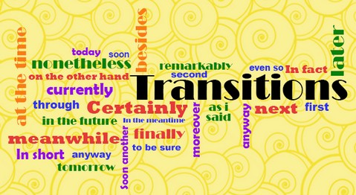
Illustration & Example Transitions: Use these for your first concrete detail (CD 1)
For example,
For instance,
To begin with,
The first reason
First,
According to (author or source),
In fact,
Although
In other words,
Specifically,

Addition Transitions: Use these for your second concrete detail (CD 2)
Furthermore,
In addition to
Moreover,
Secondly,
Next,
Besides,
Equally important,
In fact,
At the same time,
Similarly,
Likewise,
As a result,
However,
Otherwise,

Contrast Transitions:
But,
However,
Nevertheless,
In spite of
Yet,
On one hand,
On the other hand,
Rather,
At the same time,
While this may be true,

Consequence or Result:
Consequently,
Hence,
Accordingly,
Therefore,
As a result,
In other words,

Suggestion:
For this purpose,
With this in mind,

